***Name : HIMANSHU DIXIT***

***Enrollment Number: B64178***

***Batch: B10***

***Physics lab 1: V2 EXAM***

***Experiment :(BREWSTER’S ANGLE)***

***Aim:***

 To verify the Brewster's law and to find the Brewster's angle.

***Formula Used:***

*tanX = n’/n*

*where,*

*X is the Brewster angle.*

*n’ is the refractive index of reflecting surface.*

*n is the refractive index of surrounding medium.*

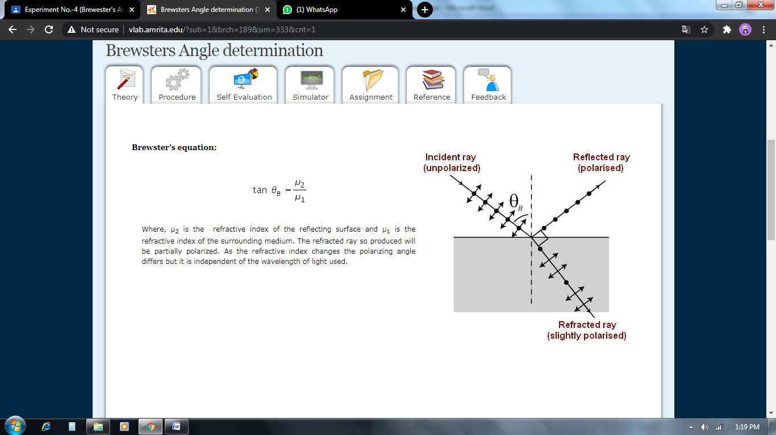

***Obesevation table:***

*1. Refractive index of medium(air) is: 1*

*2. Refractive index of material(topaz) is: 1.607*

|  |  |
| --- | --- |
| ***Incidence angle*** | ***Current(ampere)*** |
| *-70 degree* | *3.6972* |
| *-60 degree* | *1.0793* |
| *-58.1 degree* | *1.0000* |
| *-50 degree* | *2.3588* |
| *-40 degree* | *6.1741* |
| *-30 degree* | *9.2719* |
| *-20 degree* | *10.6032* |
| *-10 degree* | *10.9416* |
| *-5 degree* | *10.9810* |
| *0 degree* | *10.9945* |
| *5 degree* | *10.9810* |
| *10 degree* | *10.9416* |
| *20 degree* | *10.6032* |
| *30 degree* | *9.2719* |
| *40 degree* | *6.1741* |
| *50 degree* | *2.3588* |
| *58.1 degree* | *1.0000* |
| *60 degree* | *1.0793* |
| *70 degree* | *3.6972* |

***Graph:***

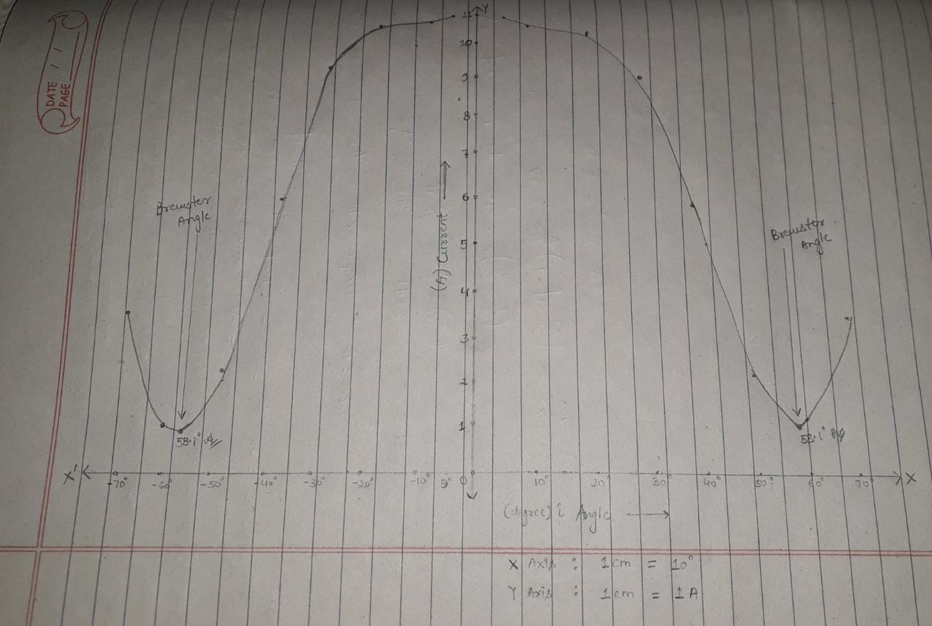

***Calculation:***

*Brewster angle(X) : tanX = n’/n = 1.607/1.000.*

*X = 58.106 == 58.11 degree.*

***Result:***

***1. By simulater :*** *Brewster angle = 58.11 degree.*

***2. By calculation :*** *Brewster angle = 58.11 degree.*

***Precautions:***

***1.*** *The photo detector should be as away from slit as possible.*

***2.*** *The laser beam should not penetrate into eyes.*

***3.*** *Scale should be rotated slowly.*

